**How to download noaa data (the best source) – We are using This!  \*\*\*\***

<https://www.google.com/url?sa=t&rct=j&q=&esrc=s&source=web&cd=&ved=2ahUKEwi5h-qBypH2AhXwj4kEHaq-CGMQFnoECAMQAw&url=https%3A%2F%2Fwww.ars.usda.gov%2FARSUserFiles%2F30980500%2FHowtoWeather2.docx&usg=AOvVaw2EgoOLVsgkGeDm2hTB6Ecu>

1. Go to <http://www.ncdc.noaa.gov/cdo-web/>
2. Click on the Search Tool.
3. Select Weather Observation Type/Dataset and select **Daily Summaries.**
4. Select Date Range using the calendar button (*Be sure to get daily weather data for 365/366 days of the year*).
5. Search for and choose the appropriate search type you will be using (typically we select **Stations).**
6. Enter a Search Term.
7. Click the **Search** button.

Now you should see a map of possible stations. You can navigate this just like Google Maps. Click on a square blue radio tower to see a summary of the station’s available data. The details show the **Latitude/Longitude** and the time **Period** they have weather data. Choose a site with as close to 100% **Coverage** to have the least amount of holes in your data. You can also click on the Full Details button or the station name on the left site of the screen to connect you to additional details of the station’s data.

1. Select a specific weather station by clicking on the orange **Add** or **Add to Cart** button depending on which method you used to find the station.
2. Click the orange **Cart** when you have added the station you want.
3. Review your Cart to make sure that the date range and stations name are what you selected.
4. Select the Output Format click on **Custom GHCN-Daily CSV.**
5. Click **Continue.**
6. Select the features you wish to receive.
7. Click **Continue.**
8. Enter email address and verify email address.
9. Click **Submit Order**.
10. You will receive an email saying that you requested data and another one saying the request is complete.
11. Click on the link at the top in the green box or the download data link, and save.
12. Open with EXCEL and format the data as shown below.

Step 8 Screen shot:

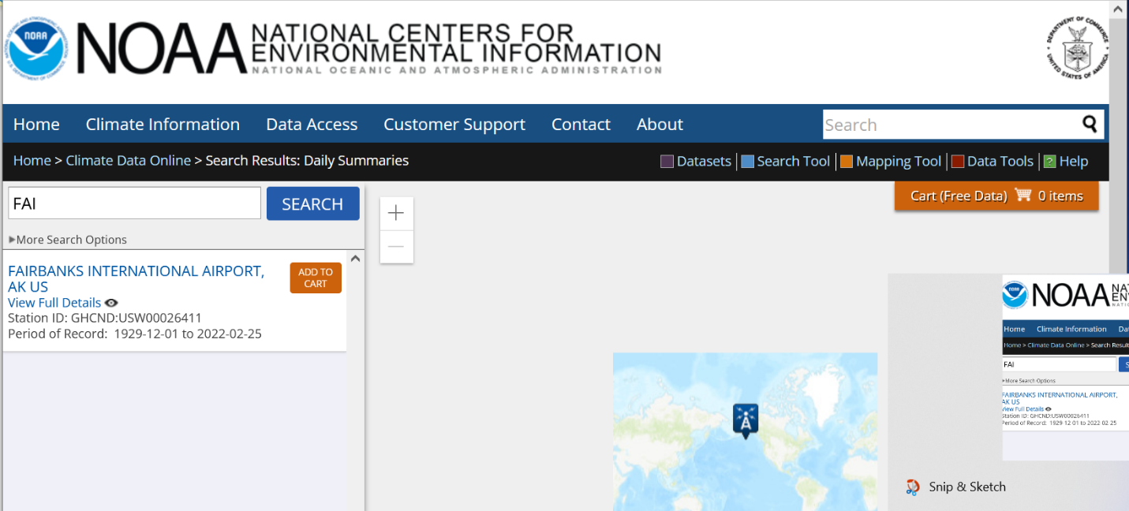[Text Wrapping Break]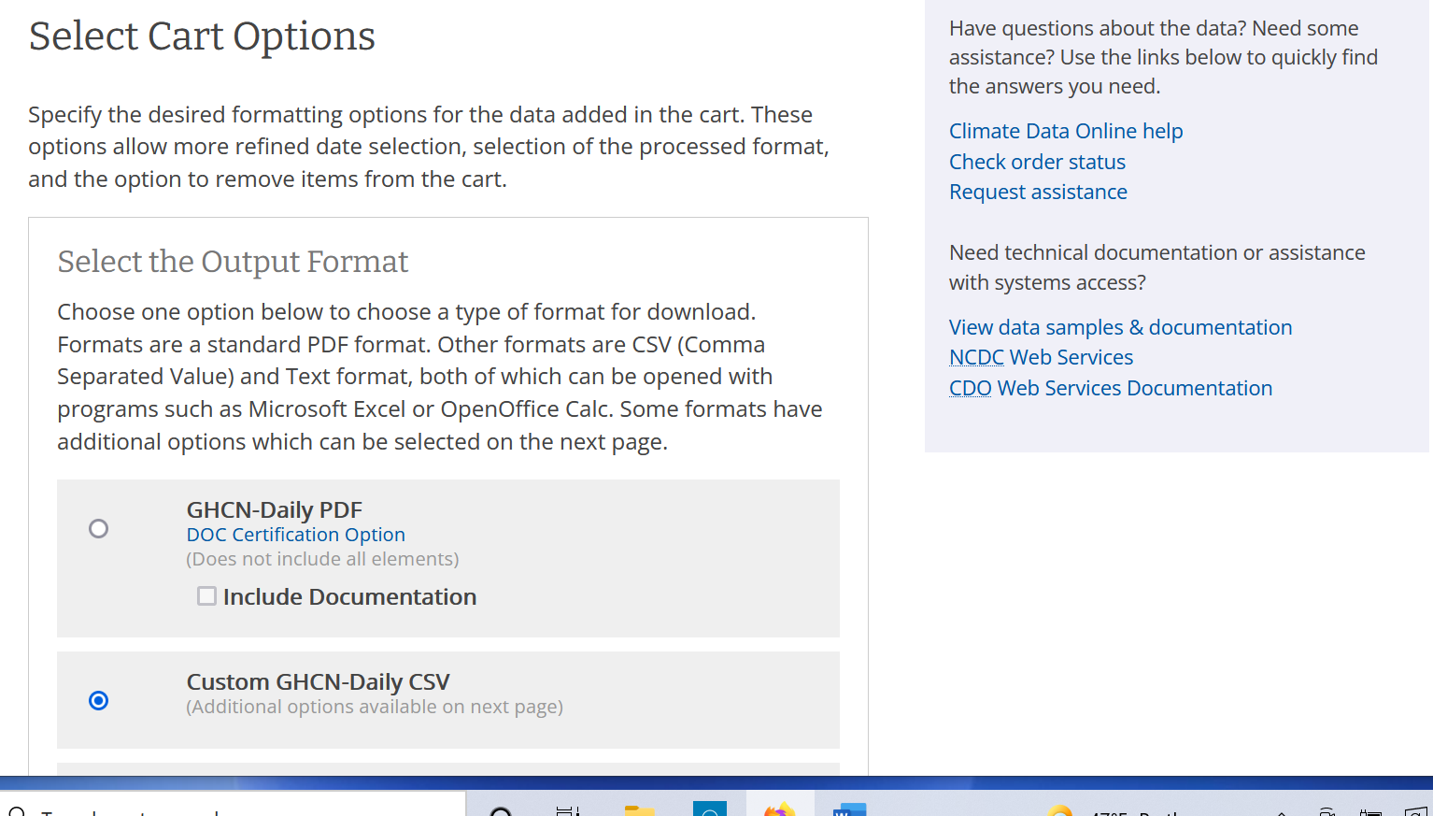

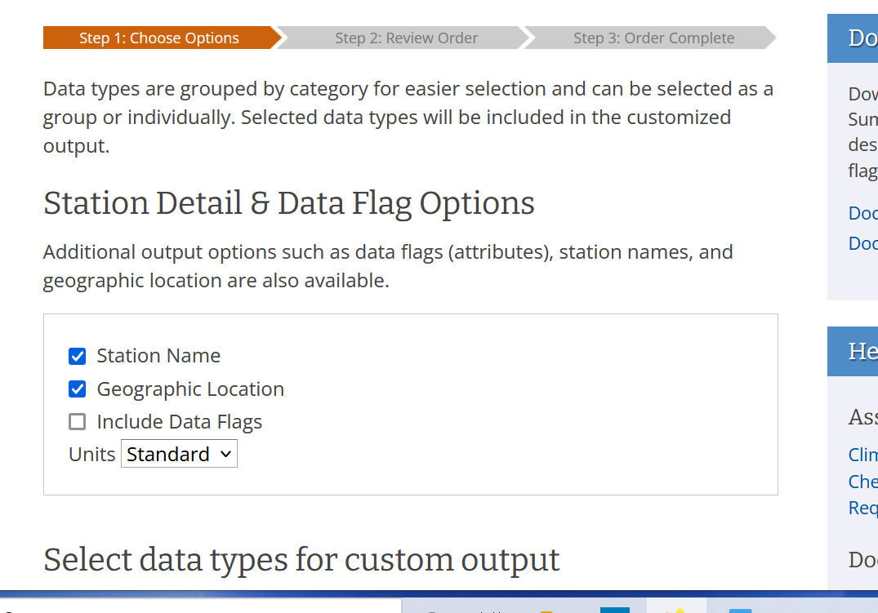

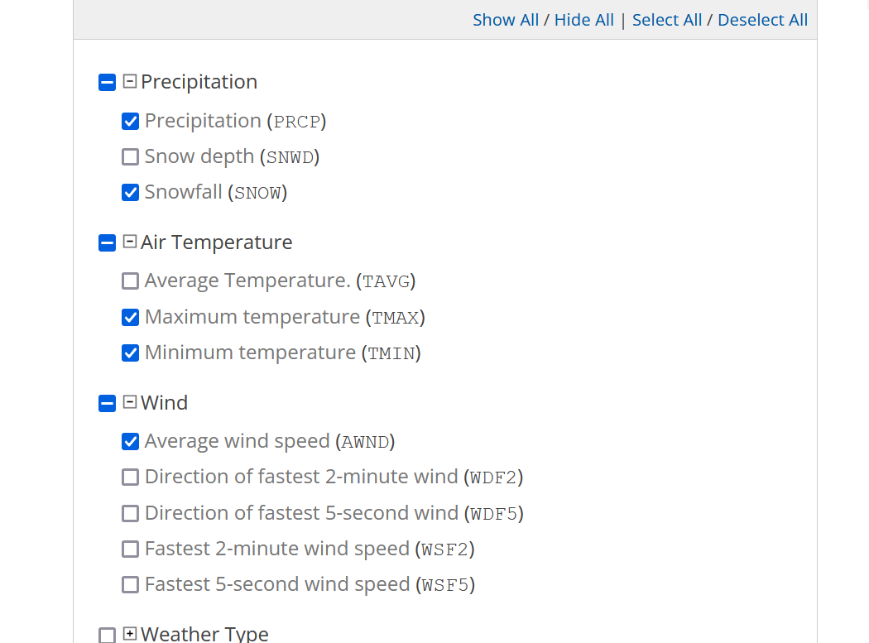

Top of Form

For noaa Daily Summaries Data set citation

[https://www.ncei.noaa.gov/metadata/geoportal/rest/metadata/item/gov.noaa.ncdc:C00861/html#](https://www.ncei.noaa.gov/metadata/geoportal/rest/metadata/item/gov.noaa.ncdc:C00861/html)

* Cite as: Menne, Matthew J., Imke Durre, Bryant Korzeniewski, Shelley McNeill, Kristy Thomas, Xungang Yin, Steven Anthony, Ron Ray, Russell S. Vose, Byron E.Gleason, and Tamara G. Houston (2012): Global Historical Climatology Network - Daily (GHCN-Daily), Version 3. [indicate subset used]. NOAA National Climatic Data Center. doi:10.7289/V5D21VHZ [access date].
* Publications citing this dataset should also cite the following article: Matthew J. Menne, Imke Durre, Russell S. Vose, Byron E. Gleason, and Tamara G. Houston, 2012: An Overview of the Global Historical Climatology Network-Daily Database. J. Atmos. Oceanic Technol., 29, 897-910. doi:10.1175/JTECH-D-11-00103.1.

**Procedure to download TowerOps data  -THIS IS WHAT WE ARE USING**

**See screen shots below and the link** <https://aspm.faa.gov>

<https://aspm.faa.gov>

This link below describes a report comparing CountOps and OPSNET Tower Comparison numbers to show how they were trying to validate the numbers

https://aspm.faa.gov/aspmhelp/index/CountOps__CountOps/OPSNET_Tower_Comparison_Report.html

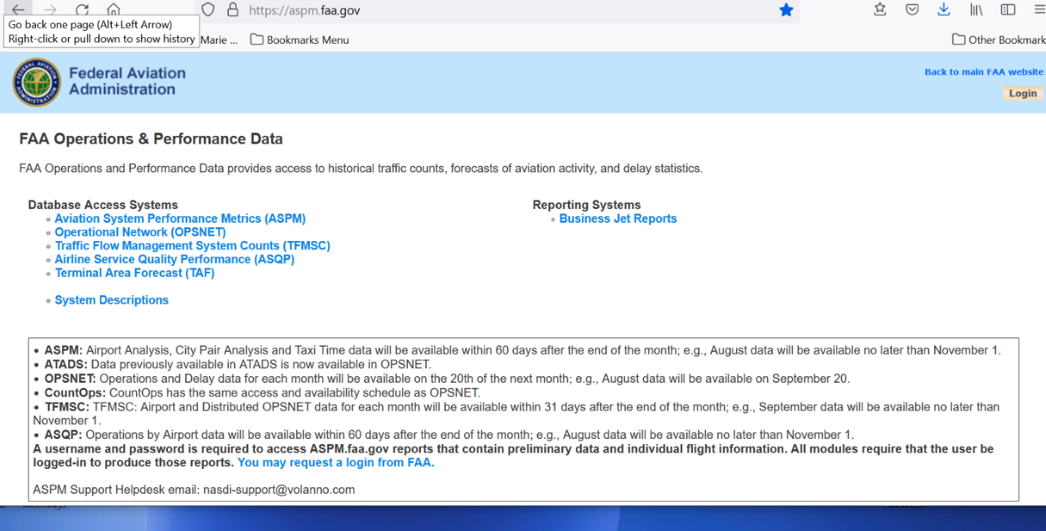

Choose OPSNET

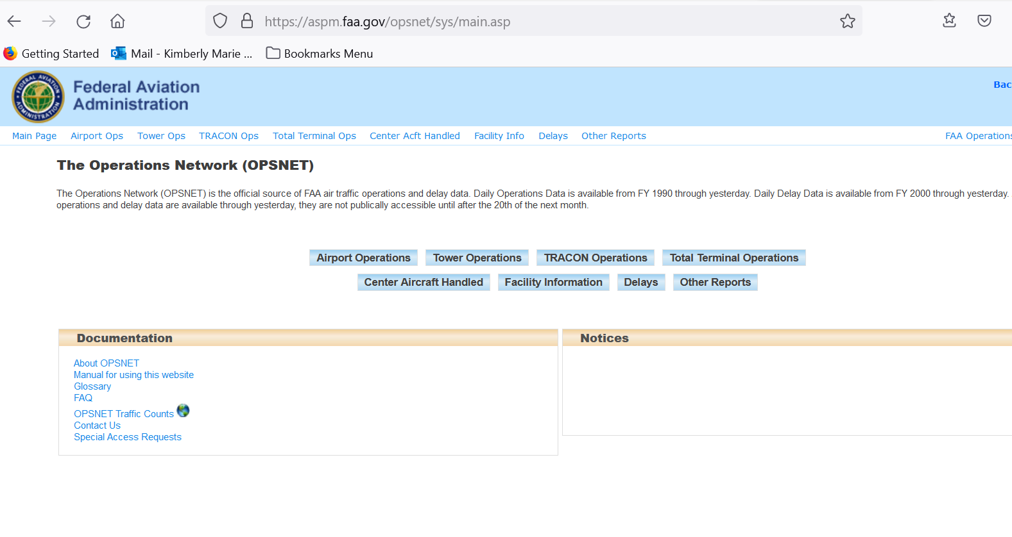

Choose tower Operations

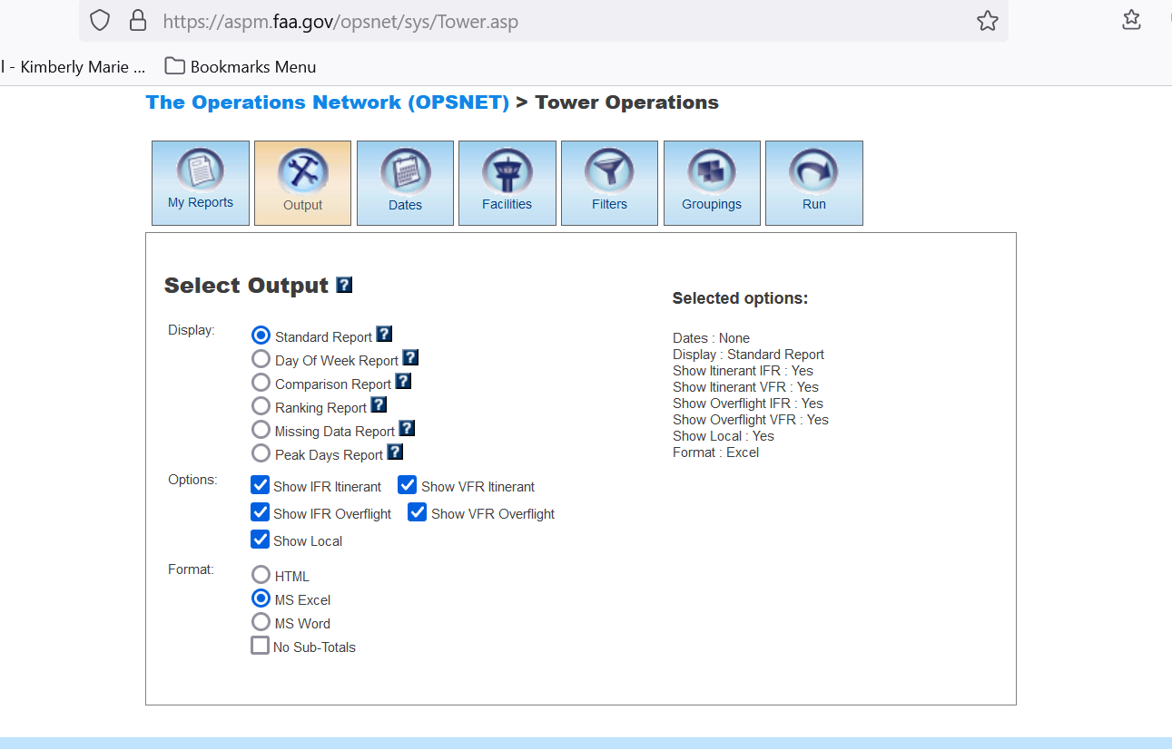

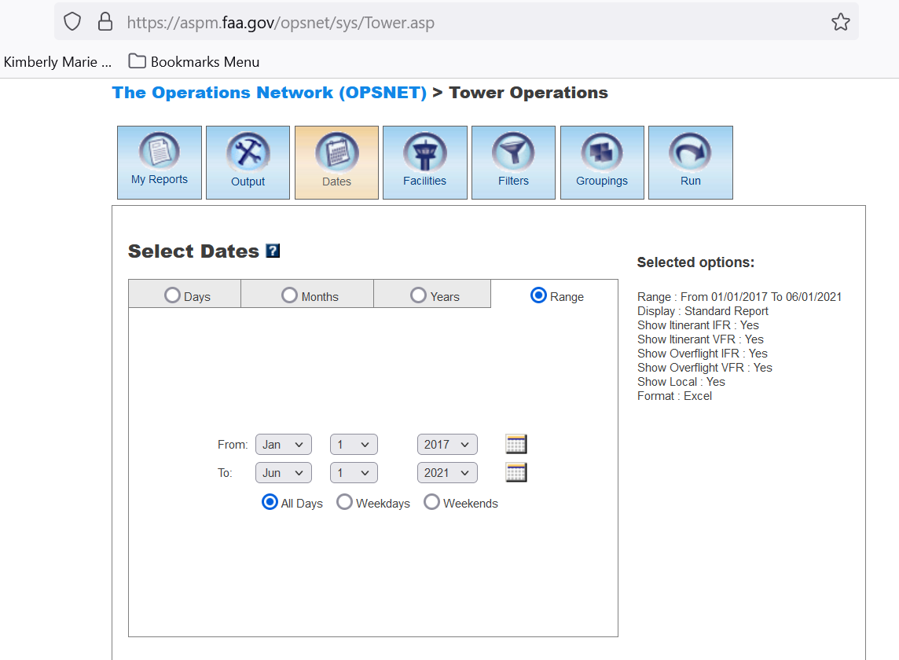

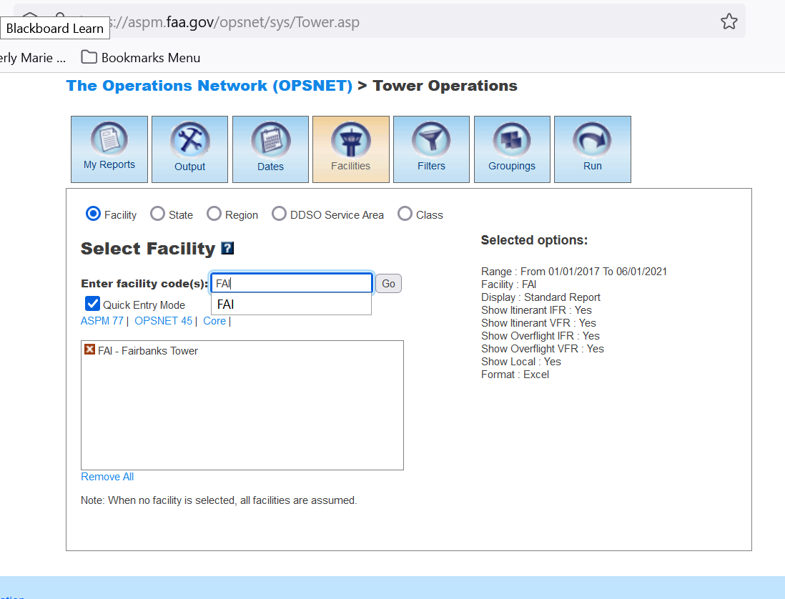

Enter Airport and click Go

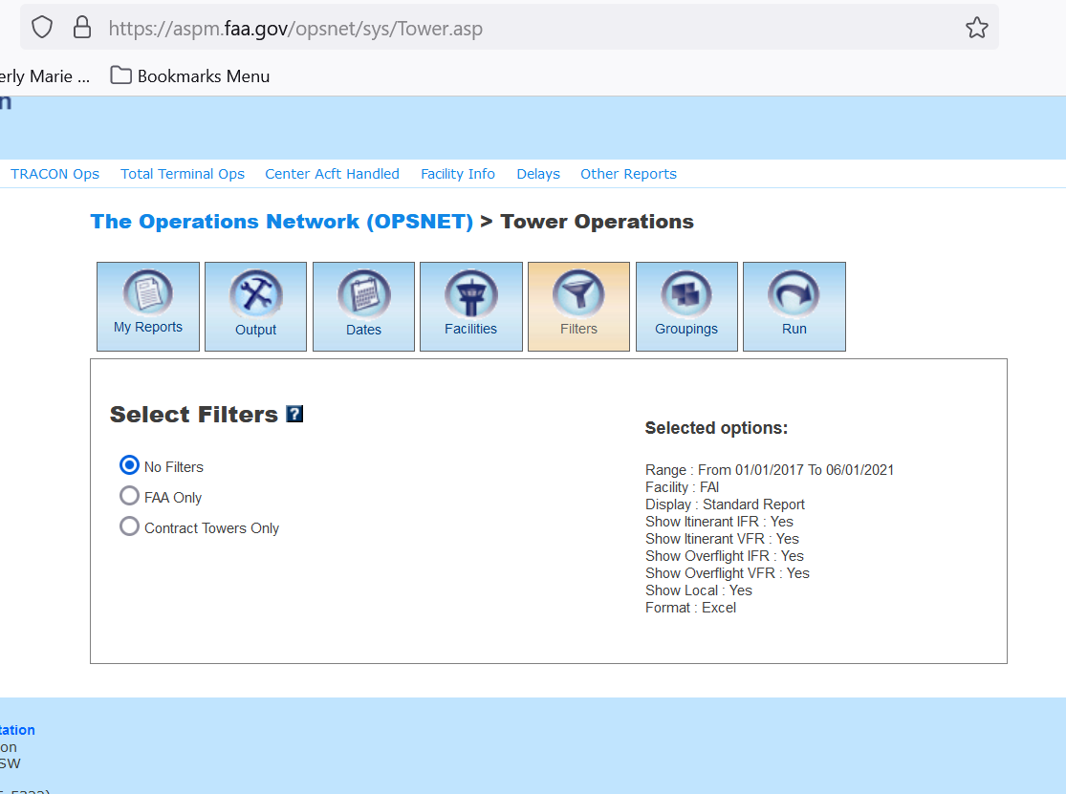

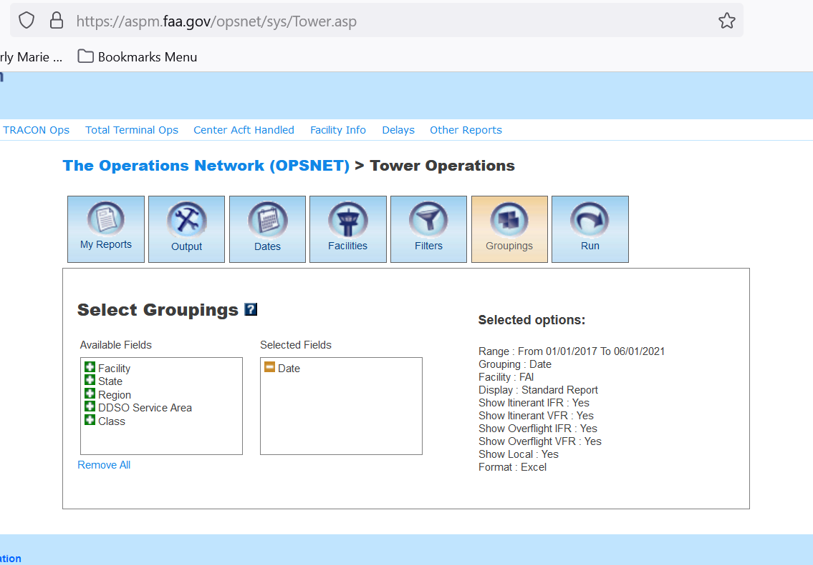

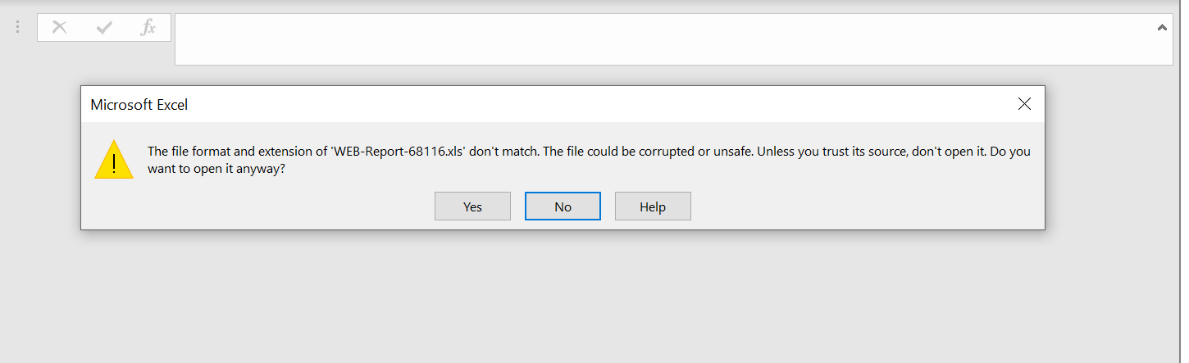

Say yes

**OPSNET Reports: Definitions of Variables**

<https://aspm.faa.gov/aspmhelp/index/OPSNET_Reports__Definitions_of_Variables.html>

**OPSNET Manual**

<https://aspm.faa.gov/aspmhelp/index/OPSNET_Manual.html#Definitions_of_Variables>

**Open Weather API**

**To Subscribe and get your API KEY**

<https://openweathermap.org/api>

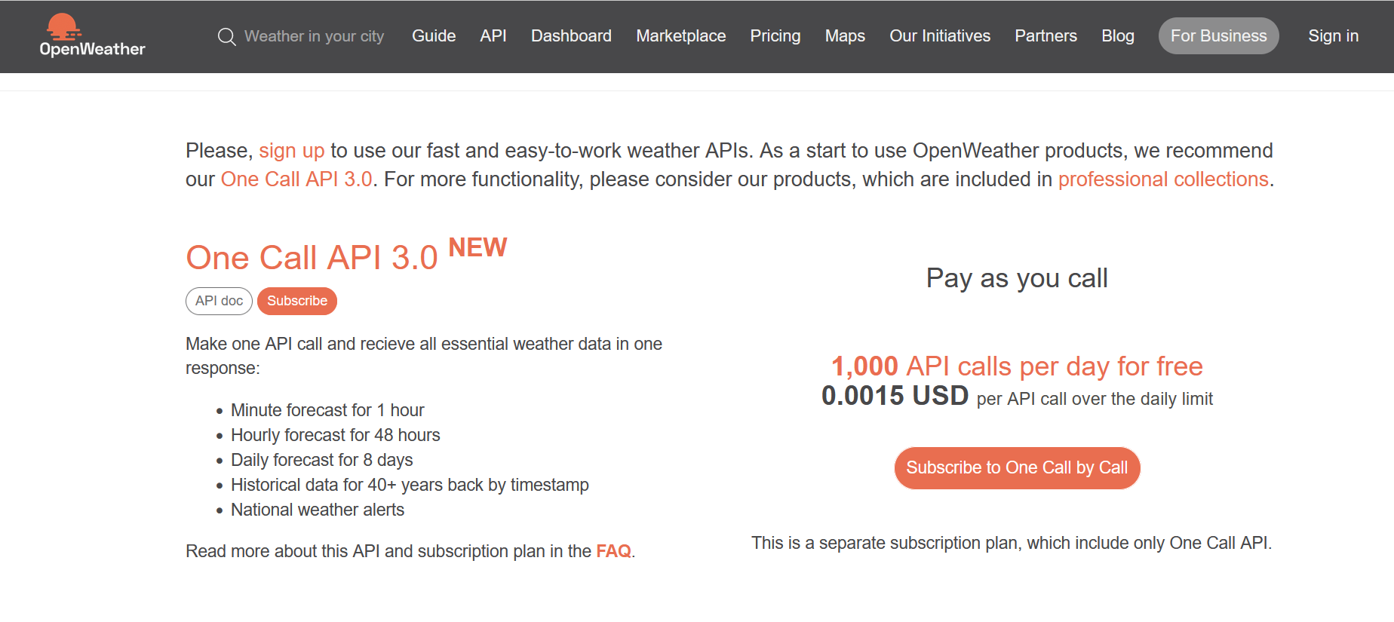

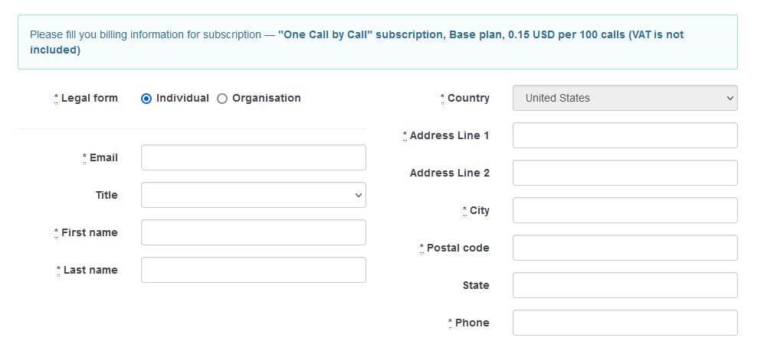

**Documentation for One Call API 3.0**

<https://openweathermap.org/api/one-call-3>

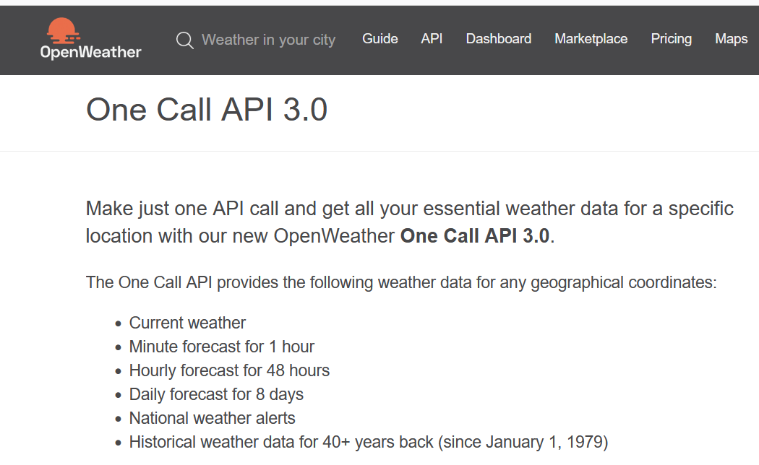

## Current and forecast weather data

To get access to current weather, minute forecast for 1 hour, hourly forecast for 48 hours, daily forecast for 8 days and government weather alerts, please use this section of the documentation.

If you are interested in **historical weather data**, please read the ["Historical weather data" section](https://openweathermap.org/api/one-call-3#history).

### How to make an API call

API call

https://api.openweathermap.org/data/3.0/onecall?lat={lat}&lon={lon}&exclude={part}&appid=[{API key}](https://home.openweathermap.org/api_keys)

|  |  |  |
| --- | --- | --- |
| **Parameters** | | |
| lat, lon | required | Geographical coordinates (latitude, longitude) |
| appid | required | Your unique API key (you can always find it on your account page under the ["API key" tab](https://home.openweathermap.org/api_keys)) |
| exclude | optional | By using this parameter you can exclude some parts of the weather data from the API response. It should be a comma-delimited list (without spaces).  Available values:   * current * minutely * hourly * daily * alerts |
| units | optional | Units of measurement. standard, metric and imperial units are available. If you do not use the units parameter, standard units will be applied by default. [Learn more](https://openweathermap.org/api/one-call-3#data) |
| lang | optional | You can use the lang parameter to get the output in your language. [Learn more](https://openweathermap.org/api/one-call-3#multi) |

Example of API call

https://api.openweathermap.org/data/3.0/onecall?lat=33.44&lon=-94.04&exclude=hourly,daily&appid=[{API key}](https://home.openweathermap.org/api_keys)

Example of API response

Example of API response

{

"lat": 39.31,

"lon": -74.5,

"timezone": "America/New_York",

"timezone_offset": -18000,

"current": {

"dt": 1646318698,

"sunrise": 1646306882,

"sunset": 1646347929,

"temp": 282.21,

"feels_like": 278.41,

"pressure": 1014,

"humidity": 65,

"dew_point": 275.99,

"uvi": 2.55,

"clouds": 40,

"visibility": 10000,

"wind_speed": 8.75,

"wind_deg": 360,

"wind_gust": 13.89,

"weather": [

{

"id": 802,

"main": "Clouds",

"description": "scattered clouds",

"icon": "03d"

}

]

},

"minutely": [

{

"dt": 1646318700,

"precipitation": 0

},

...

},

"hourly": [

{

"dt": 1646316000,

"temp": 281.94,

"feels_like": 278.49,

"pressure": 1014,

"humidity": 67,

"dew_point": 276.16,

"uvi": 1.49,

"clouds": 52,

"visibility": 10000,

"wind_speed": 7.16,

"wind_deg": 313,

"wind_gust": 10.71,

"weather": [

{

"id": 803,

"main": "Clouds",

"description": "broken clouds",

"icon": "04d"

}

],

"pop": 0.03

},

...

}

"daily": [

{

"dt": 1646326800,

"sunrise": 1646306882,

"sunset": 1646347929,

"moonrise": 1646309880,

"moonset": 1646352120,

"moon_phase": 0.03,

"temp": {

"day": 281.63,

"min": 271.72,

"max": 282.21,

"night": 271.72,

"eve": 277.99,

"morn": 280.92

},

"feels_like": {

"day": 277.83,

"night": 264.72,

"eve": 273.35,

"morn": 277.66

},

"pressure": 1016,

"humidity": 55,

"dew_point": 273.12,

"wind_speed": 9.29,

"wind_deg": 3,

"wind_gust": 16.48,

"weather": [

{

"id": 500,

"main": "Rain",

"description": "light rain",

"icon": "10d"

}

],

"clouds": 49,

"pop": 0.25,

"rain": 0.11,

"uvi": 3.38

},

...

},

"alerts": [

{

"sender_name": "NWS Philadelphia - Mount Holly (New Jersey, Delaware, Southeastern Pennsylvania)",

"event": "Small Craft Advisory",

"start": 1646344800,

"end": 1646380800,

"description": "...SMALL CRAFT ADVISORY REMAINS IN EFFECT FROM 5 PM THIS\nAFTERNOON TO 3 AM EST FRIDAY...\n* WHAT...North winds 15 to 20 kt with gusts up to 25 kt and seas\n3 to 5 ft expected.\n* WHERE...Coastal waters from Little Egg Inlet to Great Egg\nInlet NJ out 20 nm, Coastal waters from Great Egg Inlet to\nCape May NJ out 20 nm and Coastal waters from Manasquan Inlet\nto Little Egg Inlet NJ out 20 nm.\n* WHEN...From 5 PM this afternoon to 3 AM EST Friday.\n* IMPACTS...Conditions will be hazardous to small craft.",

"tags": [

]

},

...

]

Fields in API response

If you do not see some of the parameters in your API response it means that these weather phenomena are just not happened for the time of measurement for the city or location chosen. Only really measured or calculated data is displayed in API response.

* lat Geographical coordinates of the location (latitude)
* lon Geographical coordinates of the location (longitude)
* timezone Timezone name for the requested location
* timezone_offset Shift in seconds from UTC
* current **Current weather data API response**
  + current.dt Current time, Unix, UTC
  + current.sunrise Sunrise time, Unix, UTC
  + current.sunset Sunset time, Unix, UTC
  + current.temp Temperature. Units - default: kelvin, metric: Celsius, imperial: Fahrenheit. [How to change units used](https://openweathermap.org/api/one-call-3#data)
  + current.feels_like Temperature. This temperature parameter accounts for the human perception of weather. Units – default: kelvin, metric: Celsius, imperial: Fahrenheit.
  + current.pressure Atmospheric pressure on the sea level, hPa
  + current.humidity Humidity, %
  + current.dew_point Atmospheric temperature (varying according to pressure and humidity) below which water droplets begin to condense and dew can form. Units – default: kelvin, metric: Celsius, imperial: Fahrenheit.
  + current.clouds Cloudiness, %
  + current.uvi Current UV index
  + current.visibility Average visibility, metres. The maximum value of the visibility is 10km
  + current.wind_speed Wind speed. Wind speed. Units – default: metre/sec, metric: metre/sec, imperial: miles/hour. [How to change units used](https://openweathermap.org/api/one-call-3#data)
  + current.wind_gust (where available) Wind gust. Units – default: metre/sec, metric: metre/sec, imperial: miles/hour. [How to change units used](https://openweathermap.org/api/one-call-3#data)
  + current.wind_deg Wind direction, degrees (meteorological)
  + current.rain
    - current.rain.1h (where available) Rain volume for last hour, mm
  + current.snow
    - current.snow.1h (where available) Snow volume for last hour, mm
  + current.weather
    - current.weather.id [Weather condition id](https://openweathermap.org/weather-conditions#Weather-Condition-Codes-2)
    - current.weather.main Group of weather parameters (Rain, Snow, Extreme etc.)
    - current.weather.description Weather condition within the group ([full list of weather conditions](https://openweathermap.org/weather-conditions#Weather-Condition-Codes-2)). Get the output in [your language](https://openweathermap.org/api/one-call-api#multi)
    - current.weather.icon Weather icon id. [How to get icons](https://openweathermap.org/weather-conditions#How-to-get-icon-URL)
* minutely **Minute forecast weather data API response**
  + minutely.dt Time of the forecasted data, unix, UTC
  + minutely.precipitation Precipitation volume, mm
* hourly **Hourly forecast weather data API response**
  + hourly.dt Time of the forecasted data, Unix, UTC
  + hourly.temp Temperature. Units – default: kelvin, metric: Celsius, imperial: Fahrenheit. [How to change units used](https://openweathermap.org/api/one-call-3#data)
  + hourly.feels_like Temperature. This accounts for the human perception of weather. Units – default: kelvin, metric: Celsius, imperial: Fahrenheit.
  + hourly.pressure Atmospheric pressure on the sea level, hPa
  + hourly.humidity Humidity, %
  + hourly.dew_point Atmospheric temperature (varying according to pressure and humidity) below which water droplets begin to condense and dew can form. Units – default: kelvin, metric: Celsius, imperial: Fahrenheit.
  + hourly.uvi UV index
  + hourly.clouds Cloudiness, %
  + hourly.visibility Average visibility, metres. The maximum value of the visibility is 10km
  + hourly.wind_speed Wind speed. Units – default: metre/sec, metric: metre/sec, imperial: miles/hour.[How to change units used](https://openweathermap.org/api/one-call-3#data)
  + hourly.wind_gust (where available) Wind gust. Units – default: metre/sec, metric: metre/sec, imperial: miles/hour. [How to change units used](https://openweathermap.org/api/one-call-3#data)
  + chourly.wind_deg Wind direction, degrees (meteorological)
  + hourly.pop Probability of precipitation. The values of the parameter vary between 0 and 1, where 0 is equal to 0%, 1 is equal to 100%
  + hourly.rain
    - hourly.rain.1h (where available) Rain volume for last hour, mm
  + hourly.snow
    - hourly.snow.1h (where available) Snow volume for last hour, mm
  + hourly.weather
    - hourly.weather.id [Weather condition id](https://openweathermap.org/weather-conditions#Weather-Condition-Codes-2)
    - hourly.weather.main Group of weather parameters (Rain, Snow, Extreme etc.)
    - hourly.weather.description Weather condition within the group ([full list of weather conditions](https://openweathermap.org/weather-conditions#Weather-Condition-Codes-2)). Get the output in [your language](https://openweathermap.org/api/one-call-api#multi)
    - hourly.weather.icon Weather icon id. [How to get icons](https://openweathermap.org/weather-conditions#How-to-get-icon-URL)
* daily **Daily forecast weather data API response**
  + daily.dt Time of the forecasted data, Unix, UTC
  + daily.sunrise Sunrise time, Unix, UTC
  + daily.sunset Sunset time, Unix, UTC
  + daily.moonrise The time of when the moon rises for this day, Unix, UTC
  + daily.moonset The time of when the moon sets for this day, Unix, UTC
  + daily.moon_phase Moon phase. 0 and 1 are 'new moon', 0.25 is 'first quarter moon', 0.5 is 'full moon' and 0.75 is 'last quarter moon'. The periods in between are called 'waxing crescent', 'waxing gibous', 'waning gibous', and 'waning crescent', respectively.
  + daily.temp Units – default: kelvin, metric: Celsius, imperial: Fahrenheit. [How to change units used](https://openweathermap.org/api/one-call-3#data)
    - daily.temp.morn Morning temperature.
    - daily.temp.day Day temperature.
    - daily.temp.eve Evening temperature.
    - daily.temp.night Night temperature.
    - daily.temp.min Min daily temperature.
    - daily.temp.max Max daily temperature.
  + daily.feels_like This accounts for the human perception of weather. Units – default: kelvin, metric: Celsius, imperial: Fahrenheit. [How to change units used](https://openweathermap.org/api/one-call-3#data)
    - daily.feels_like.morn Morning temperature.
    - daily.feels_like.day Day temperature.
    - daily.feels_like.eve Evening temperature.
    - daily.feels_like.night Night temperature.
  + daily.pressure Atmospheric pressure on the sea level, hPa
  + daily.humidity Humidity, %
  + daily.dew_point Atmospheric temperature (varying according to pressure and humidity) below which water droplets begin to condense and dew can form. Units – default: kelvin, metric: Celsius, imperial: Fahrenheit.
  + daily.wind_speed Wind speed. Units – default: metre/sec, metric: metre/sec, imperial: miles/hour. [How to change units used](https://openweathermap.org/api/one-call-3#data)
  + daily.wind_gust (where available) Wind gust. Units – default: metre/sec, metric: metre/sec, imperial: miles/hour. [How to change units used](https://openweathermap.org/api/one-call-3#data)
  + daily.wind_deg Wind direction, degrees (meteorological)
  + daily.clouds Cloudiness, %
  + daily.uvi The maximum value of UV index for the day
  + daily.pop Probability of precipitation. The values of the parameter vary between 0 and 1, where 0 is equal to 0%, 1 is equal to 100%
  + daily.rain (where available) Precipitation volume, mm
  + daily.snow (where available) Snow volume, mm
  + daily.weather
    - daily.weather.id [Weather condition id](https://openweathermap.org/weather-conditions#Weather-Condition-Codes-2)
    - daily.weather.main Group of weather parameters (Rain, Snow, Extreme etc.)
    - daily.weather.description Weather condition within the group ([full list of weather conditions](https://openweathermap.org/weather-conditions#Weather-Condition-Codes-2)). Get the output in [your language](https://openweathermap.org/api/one-call-api#multi)
    - daily.weather.icon Weather icon id. [How to get icons](https://openweathermap.org/weather-conditions#How-to-get-icon-URL)
* alerts **National weather alerts data from major national weather warning systems**
  + alerts.sender_name Name of the alert source. Please read here the [full list of alert sources](https://openweathermap.org/api/one-call-3#listsource)
  + alerts.event Alert event name
  + alerts.start Date and time of the start of the alert, Unix, UTC
  + alerts.end Date and time of the end of the alert, Unix, UTC
  + alerts.description Description of the alert
  + alerts.tags Type of severe weather

National weather alerts are provided in English by default.  
Please note that some agencies provide the alert’s description only in a local language.

**Main openweather site and general info**

[**https://openweathermap.org/**](https://openweathermap.org/)

### List of weather condition codes

List of [weather condition codes](https://openweathermap.org/weather-conditions) with icons (range of thunderstorm, drizzle, rain, snow, clouds, atmosphere including extreme conditions like tornado, hurricane etc.)

## Other features

### Units of measurement

standard, metric and imperial units are available.

[List of all API parameters with available units.](http://openweathermap.org/weather-data)

API call

http://api.openweathermap.org/data/3.0/onecall?lat={lat}&lon={lon}&units={units}

|  |  |  |
| --- | --- | --- |
| **Parameters** | | |
| units | optional | Units of measurement. standard, metric and imperial units are available. If you do not use the units parameter, standard units will be applied by default. |

Temperature is available in Fahrenheit, Celsius and Kelvin units.

Wind speed is available in miles/hour and meter/sec.

* For temperature in Fahrenheit and wind speed in miles/hour, use units=imperial
* For temperature in Celsius and wind speed in meter/sec, use units=metric
* Temperature in Kelvin and wind speed in meter/sec is used by default, so there is no need to use the units parameter in the API call if you want this

Examples of API calls

Standard (default)

api.openweathermap.org/data/3.0/onecall?lat=30.489772&lon=-99.771335

Metric

api.openweathermap.org/data/3.0/onecall?lat=30.489772&lon=-99.771335&units=metric

Imperial

api.openweathermap.org/data/3.0/onecall?lat=30.489772&lon=-99.771335&units=imperial

**Unix UTC internet explanation – used in daily:dt field for Open Weather**

<https://kb.narrative.io/what-is-unix-time>

**Convert epoch to human-readable date and vice versa**

<https://www.epochconverter.com/>

**Convert Unix time to datetime: fromtimestamp()**

<https://note.nkmk.me/en/python-unix-time-datetime/>

**Holiday csv**

near_weekend_holiday_dates.csv

Contains dates surrounding holidays and weekends which may have higher volume for certain airports.

This information is displayed in the Tableau Dashboard for each airport.

